**NAME –POOJA KUMARI**

**REF-SIRSS2329**

**COLLEGE-MAHARAJA SURAJMAL INSTITUTE OF TECHNOLOGY**

**ASSIGNMENT 12**

**QUE-WRITE A BLOG/ARTICLE ON "FACE DETECTION IN LIVE VIDEO FEED"**

**FACE DETECTION IN LIVE VIDEO FEED**

### **WHAT IS FACE DETECTION?**

Face detection -- also called facial detection -- is an artificial intelligence (AI) basedcomputer technology used to find and identify human faces in digital images. Face detection has a significant effect on how sequential operations will perform in the application.

### **HOW FACE DETECTION WORKS**

Face detection applications use algorithms and ML to find human faces within larger images, which often incorporate other non-face objects such as landscapes, buildings and other human body parts like feet or hands. Face detection algorithms typically start by searching for human eyes -- one of the easiest features to detect. The algorithm might then attempt to detect eyebrows, the mouth, nose, nostrils and the iris. Once the algorithm concludes that it has found a facial region, it applies additional tests to confirm that it has, in fact, detected a face.

To help ensure accuracy, the algorithms need to be trained on large data sets incorporating hundreds of thousands of positive and negative images. The training improves the algorithms' ability to determine whether there are faces in an image and where they are.

**The methods used in face detection can be knowledge-based, feature-based, template matching or appearance-based. Each has advantages and disadvantages:**

* Knowledge-based, or rule-based methods, describe a face based on rules. The challenge of this approach is the difficulty of coming up with well-defined rules.
* Feature invariant methods -- which use features such as a person's eyes or nose to detect a face -- can be negatively affected by noise and light.
* Template-matching methods are based on comparing images with standard face patterns or features that have been stored previously and correlating the two to detect a face. Unfortunately these methods do not address variations in pose, scale and shape.
* Appearance-based methods employ statistical analysis and machine learning to find the relevant characteristics of face images. This method, also used in feature extraction for face recognition, is divided into sub-methods.

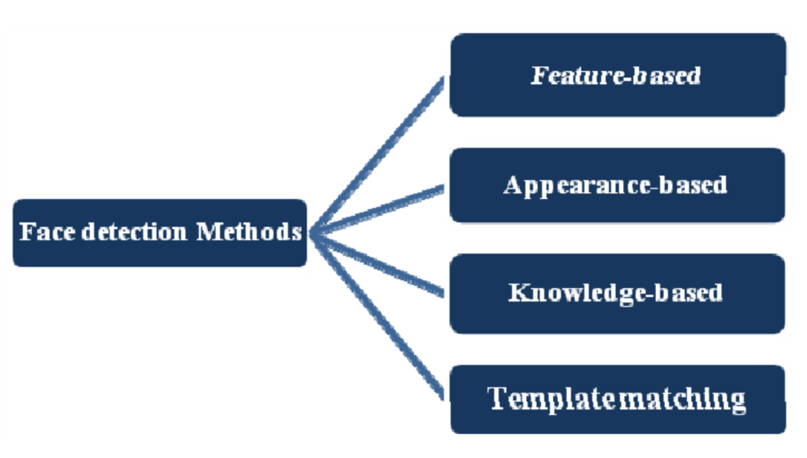

### **FACE DETECTION VS. FACE RECOGNITION**

Although the terms face detection and face recognition are often used together, facial recognition is only one application for face detection -- albeit one of the most significant ones. Facial recognition is used for unlocking phones and mobile apps as well as for Biometric verification. The banking, retail and transportation-security industries employ facial recognition to reduce crime and prevent violence.

In short, the term face recognition extends beyond detecting the presence of a human face to determine whose face it is. The process uses a computer application that captures a digital image of an individual's face -- sometimes taken from a video frame -- and compares it to images in a database of stored records.

In short, the term face recognition extends beyond detecting the presence of a human face to determine whose face it is. The process uses a computer application that captures a digital image of an individual's face -- sometimes taken from a video frame -- and compares it to images in a database of stored records

### **ADVANTAGES OF FACE DETECTION**

As a key element in facial imaging applications, such as facial recognition and face analysis, face detection creates various advantages for users, including:

* Improved security. Face detection improves surveillance efforts and helps track down criminals and terrorists. Personal security is also enhanced since there is nothing for hackers to steal or change, such as passwords.
* Easy to integrate. Face detection and facial recognition technology is easy to integrate, and most solutions are compatible with the majority of security software.
* Automated identification. In the past, identification was manually performed by a person; this was inefficient and frequently inaccurate. Face detection allows the identification process to be automated, thus saving time and increasing accuracy.

### **DISADVANTAGES OF FACE DETECTION**

While face detection provides several large benefits to users, it also holds various disadvantages, including:

* Massive data storage burden. The ML technology used in face detection requires powerful data storage that may not be available to all users.
* Detection is vulnerable. While face detection provides more accurate results than manual identification processes, it can also be more easily thrown off by changes in appearance or camera angles.
* A potential breach of privacy. Face detection's ability to help the government track down criminals creates huge benefits; however, the same surveillance can allow the government to observe private citizens. Strict regulations must be set to ensure the technology is used fairly and in compliance with human privacy rights.

### **APPLICATION OF FACE DETECTION**

1. Security companies are using facial recognition to secure their premises.

2. Immigration checkpoints use facial recognition to enforce smarter border control.

3. Fleet management companies can use face recognition to secure their vehicles.

4. Ride-sharing companies can use facial recognition to ensure the right passengers are picked up by the right drivers.

IoT benefits from facial recognition by allowing enhanced security measures and automatic access control at home.

6. Law Enforcement can use facial recognition technologies as one part of AI-driven surveillance systems.

7. Retailers can use facial recognition to customize offline offerings and to theoretically map online purchasing habits with their online ones.